# **IR Sensor**

Now a days, an Infrared technology has a wide variety of wireless applications mostly in object sensing and remote controls.

## **What is an IR Sensor?**

IR sensor is an electronic device, that emits the light in order to sense some object of the surroundings. An [**IR sensor**](https://robu.in/product-category/sensor/ir-and-pir-sensor/) can measure the heat of an object as well as detects the motion. Usually, in the [**infrared spectrum**](https://en.wikipedia.org/wiki/Infrared_spectroscopy), all the objects radiate some form of thermal radiation. These types of radiations are invisible to our eyes, but infrared sensor can detect these radiations.

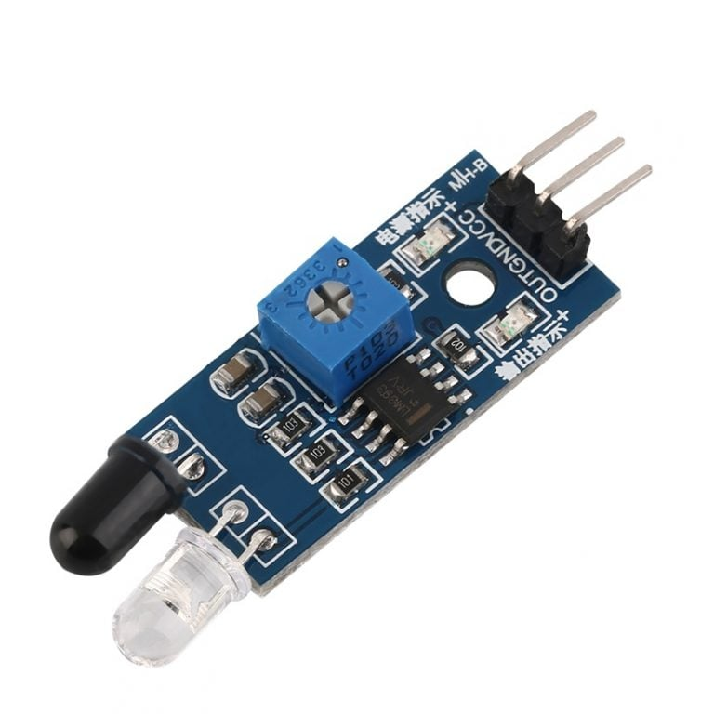

The emitter is simply an IR LED [**(Light Emitting Diode**](https://robu.in/product-category/display-boards/led/)) and the detector is simply an IR photodiode . Photodiode is sensitive to IR light of the same wavelength which is emitted by the IR LED. When IR light falls on the photodiode, the resistances and the output voltages will change in proportion to the magnitude of the IR light received.

There are five basic elements used in a typical infrared detection system: an infrared source, a transmission medium, optical component, infrared detectors or receivers and signal processing. Infrared lasers and Infrared LED’s of specific wavelength used as infrared sources.

The three main types of media used for infrared transmission are vacuum, atmosphere and optical fibers. Optical components are used to focus the infrared radiation or to limit the spectral response..

#### **Technical Specifications**

| **Specification** | **Value** |
| --- | --- |
| Sensor Type | Infrared |
| Detection Range | 0.1 to 5 meters |
| Operating Wavelength | 850 nm |
| Output Type | Analog Voltage |
| Supply Voltage | 3.3V - 5V |
| Field of View (FOV) | 60 degrees |
| Operating Temperature | -20°C to +70°C |

## **Types of IR Sensor**

There are two types of IR sensors are available and they are,

* Active Infrared Sensor
* Passive Infrared Sensor

### **Active Infrared Sensor**

Active infrared sensors consist of two elements: infrared source and infrared detector. Infrared sources include the LED or infrared [**laser diode**](https://robu.in/product-category/electronic-module/laser-module/). Infrared detectors include photodiodes or phototransistors. The energy emitted by the infrared source is reflected by an object and falls on the infrared detector.

### **Passive Infrared Sensor**

Passive infrared [**sensors**](https://robu.in/product-category/sensor/) are basically Infrared detectors. Passive infrared sensors do not use any infrared source and detector. They are of two types: quantum and thermal. Thermal infrared sensors use infrared energy as the source of heat. [**Thermocouples**](https://robu.in/product/max6675-thermocouple-sensor-module/), pyroelectric detectors and bolometers are the common types of thermal infrared detectors. Quantum type infrared sensors offer higher detection performance. It is faster than thermal type infrared detectors. The photo sensitivity of quantum type detectors is wavelength dependent.

## **IR Sensor Working Principle**

There are different types of infrared transmitters depending on their wavelengths, output power and response time. An IR sensor consists of an IR LED and an IR Photodiode, together they are called as PhotoCoupler or OptoCoupler.

**IR Transmitter or IR LED**

Infrared Transmitter is a light emitting diode (LED) which emits infrared radiations called as IR LED’s. Even though an IR LED looks like a normal LED, the radiation emitted by it is invisible to the human eye.

The picture of an Infrared LED is shown below.

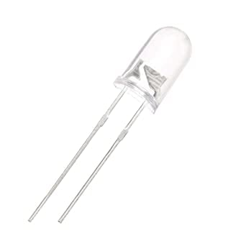

**IR Receiver or Photodiode**

Infrared receivers or infrared sensors detect the radiation from an IR transmitter. IR receivers come in the form of photodiodes and phototransistors. Infrared Photodiodes are different from normal photo diodes as they detect only infrared radiation. Below image shows the picture of an IR receiver or a photodiode,

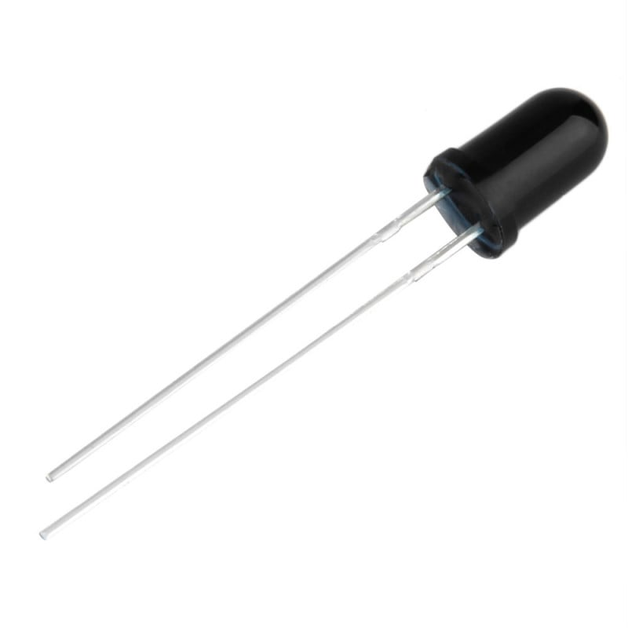

Different types of IR receivers exist based on the wavelength, voltage, package, etc. When used in an infrared transmitter – receiver combination, the wavelength of the receiver should match with that of the transmitter.

The emitter is an IR LED and the detector is an IR photodiode. The IR photodiode is sensitive to the IR light emitted by an IR LED. The photo-diode’s resistance and output voltage change in proportion to the IR light received. This is the underlying working principle of the IR sensor.

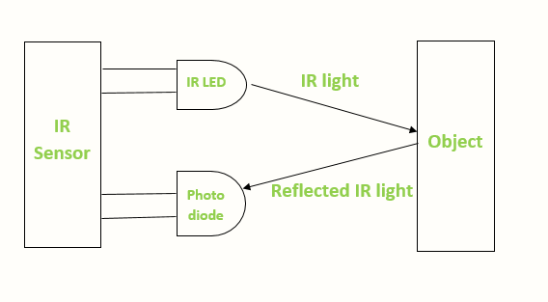

When the IR transmitter emits radiation, it reaches the object and some of the radiation reflects back to the IR receiver. Based on the intensity of the reception by the IR receiver, the output of the [**sensor**](https://robu.in/product-category/sensor/) defines.

## **IR Sensor Module Pin Diagram**

IR sensor module has 3 terminals these are OUT pin, GND pin, and VCC pin.

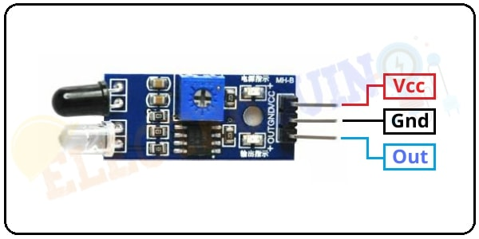

## **How to use IR Sensor Module with Arduino**

We need to connect the IR sensor with Arduino properly to read the output of the sensor. First of all, we connected the sensor **Vcc pin** to the Arduino **5v** **pin** and the **GND** pin is connected to the Arduino **ground (GND)** pin, to activate the IR sensor module. Then connect the sensor output pin to one of the digital pin of Arduino to read the output value from the IR sensor module.

## **Obstacle Detection Arduino Code**

int IRSensor = 3; // connect ir sensor to arduino pin 3

int LED = 11; // conect Led to arduino pin 13

void setup()

{

pinMode (IRSensor, INPUT); // sensor pin INPUT

pinMode (LED, OUTPUT); // Led pin OUTPUT

Serial.begin (9600); //// Starts the serial communication

}

void loop()

{

//Define a variables for read the IRsensor

int Sensordata = digitalRead (IRSensor);

// Prints the output data on the Serial Monitor

Serial.print("Sensor value:");

Serial.println(Sensordata);

if (Sensordata == 0) //Check the sensor output

{

digitalWrite(LED, HIGH); // LED High

}

else

{

digitalWrite(LED, LOW); // LED LOW

}

}

Where we assing the IRSensor pin 3 as INPUT and LED pin 11 as OUTPUT and our code is to read the value from INPUT pin , if the value is 0 make the LED to HIGH else make the LED to LOW.